**Chapter 5**

**Forms/JFrames**

**5.1. Register and login form**

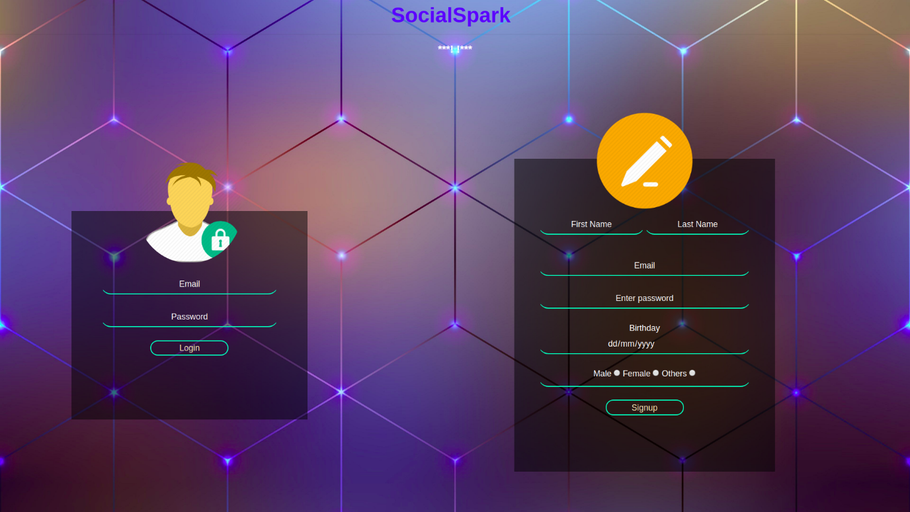

* While registration there are validation checks and also a welcome mail is send to the registered Email Id. The password is encrypted by hashing.

**5.2. Update form**

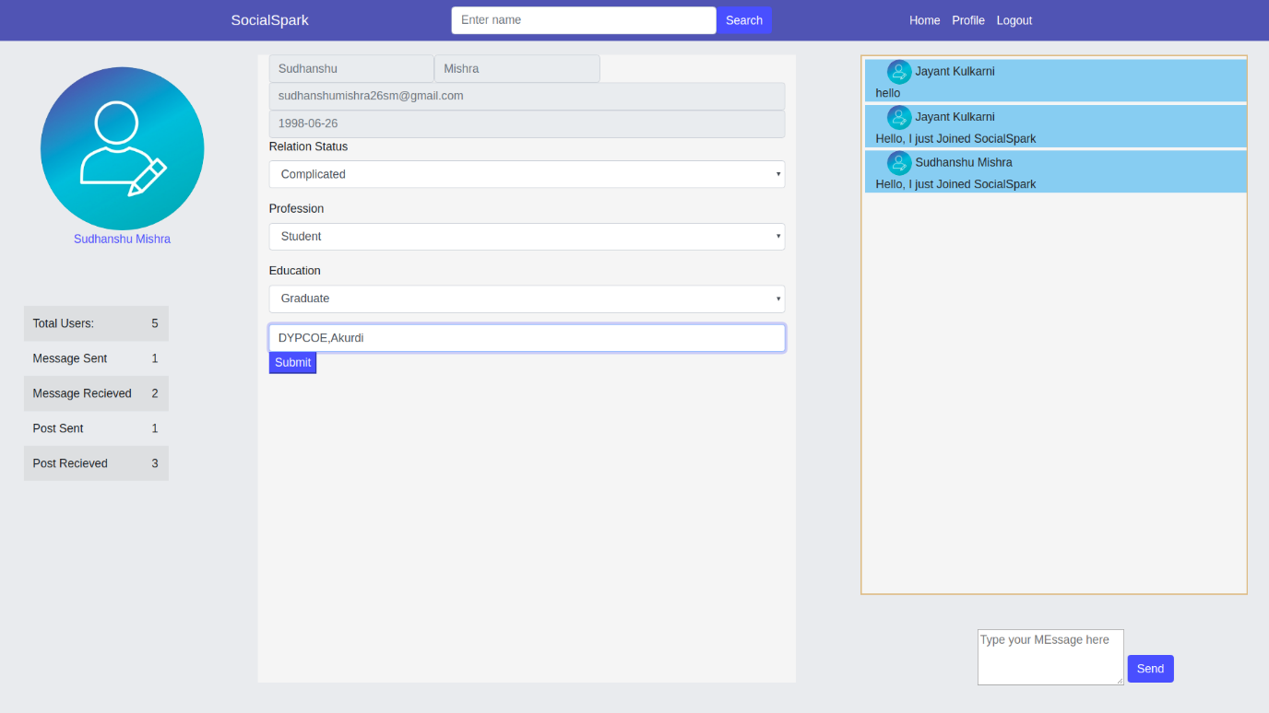

**5.2. Upload Image**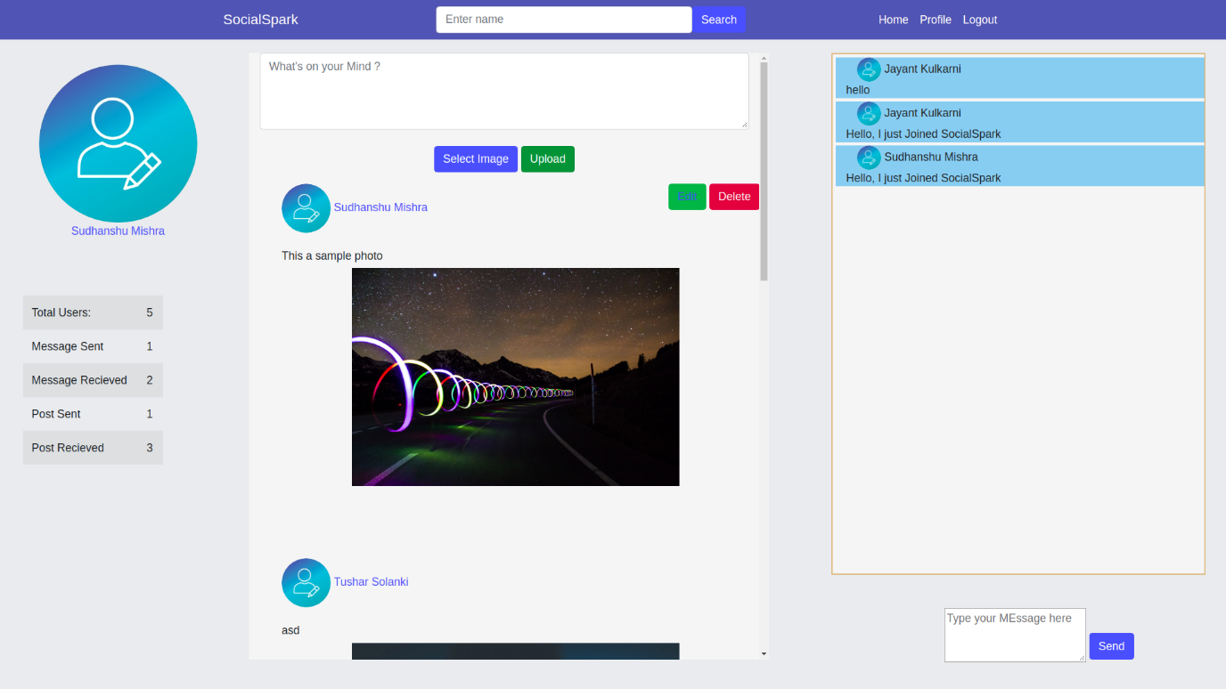

**5.2. Sending Message**

